# Experiment 1 Respiratory system using balloons

### Objective

To study the concept of respiratory system and lungs by using air in balloons.

### Equipment Required

* Plastic bottle
* Balloons
* 3-way pipe connector
* Rubber bands
* Glue gun/UHU tube

### How to Setup

1. Make a 3-way pipe connector by using straws and glue gun or UHU tube
2. Attach two balloons with the ends of the two pipes as shown
3. Make a hole in the bottle cap of the same diameter as that of the straw
4. Cut off the bottom of the bottle

### 

### ACTIVITY

1. Pass the single side of pipe through the bottle cap as shown in image
2. Cover lower end of bottle with a balloon as shown and seal the openings using glue gun
3. Pull or push the lower balloon and observe inner balloons

### Note

* The lower balloon is used for changing the air pressure in the bottle
* The upper 2 balloons work like human lungs. This experiment demonstrates the respiratory system and how we breathe in and out.

#### Question 1

Our lungs _______ when we breathe out

#### Answer

Contract

#### Question 2

How do we inhale air?

#### Answer

When we inhale, air enters our lungs through our nostrils and windpipe. Our lungs expand when we inhale air.

#### Question 3

What happens to inner balloon when we pull to outer balloon?

#### Answer

They expand.

### Useful Links

* <https://www.science-sparks.com/breathing-making-a-fake-lung/>
* <https://www.youtube.com/watch?v=DAk9mmfDhBM>

# Experiment 2 Optics in Glass

### Objective

To study and explore the refraction of light when it passes through mediums of different density.

### Equipment Required

* Drinking glass
* Water
* A small piece of paper
* Marker
* Straw

### HOW TO SETUP

1. Fill the glass half with water
2. Draw a horizontal arrow on the piece of paper

### Activity

1. You put the piece of paper behind the glass of water and slowly move it back and forth
2. Look through the glass from the front and observe the arrow
3. Dip a straw in the water
4. Look at the straw from the top and bottom of the glass
5. Then look at the straw from the side of the glass focusing on the point where the straw enters water.

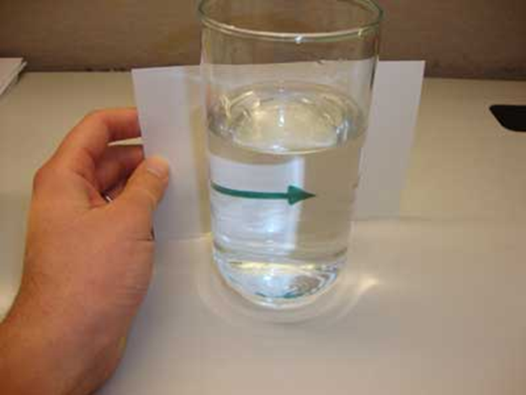 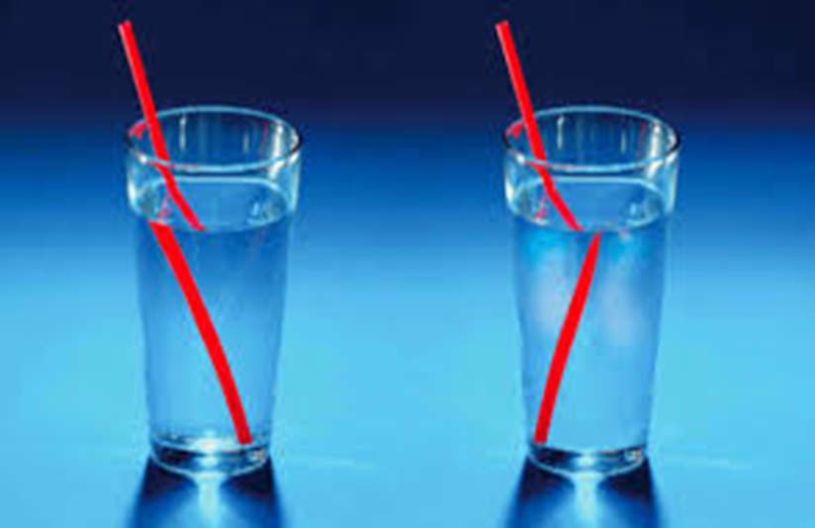

### Note

This demonstrates the phenomenon of refraction through bending of light when going from a rarer (less dense) medium to a denser medium.

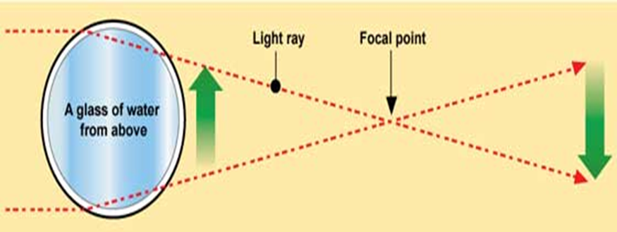

#### Question 1

Why did you observe the bend in straw?

#### Answer

It doesn’t really bend. It looks bent due to the refraction of light. That means that the light changes direction.

#### Question 2

Light travels in ________ line.

#### Answer

Straight

#### Question 3

What do you see when you move an object behind the glass?

#### Answer

It looks reverse

#### Question 4

What happens to light when it passes from air to water?

#### Answer

It bends

### Useful Links

* <http://physicscentral.com/experiment/physicsathome/reversing-arrows.cfm>
* <http://www.sciencekids.co.nz/experiments/strawbending.html>

# Experiment 3 Vegetables and Fruits as batteries

### Objective

To study the concept of generating electricity due to natural chemicals in fruits and vegetables.

### Equipment Required

* Potatoes
* Lemons
* Zinc plates
* Copper plates
* Bulbs
* Wire
* Multimeter

### HOW TO SETUP

1. Insert the copper and zinc plates into the potato connecting them in series (as shown in the figure). To connect in series, connect Zinc plate of a potato to copper plate of the next one. The two plates in one potato should not be touching.
2. Connect one end of the wire to the copper plate with a clip, then connect the other end to the multi-meter. Repeat this with the zinc plate.
3. Measure the amount of voltage the potato produces on the multi-meter.

### Activity

1. Try to power a bulb using this potato battery.
2. Use different vegetables and fruits of different sizes and explore what happens.
3. Increase and decrease number of vegetables or fruits in series and observes the change.

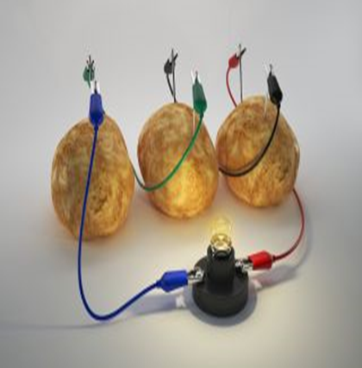 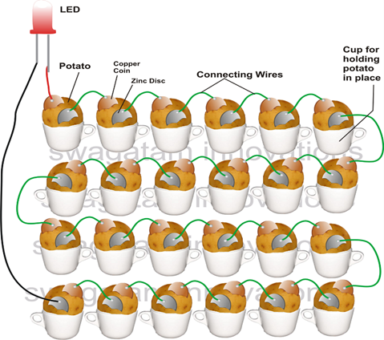

### Note

* This experiment teaches students about chemical reactions and electricity. It encourages observational and analytic skills.
* Potatoes naturally contain salt and water. Salt dissolves in water to produce a liquid that can conduct electricity.
* The liquid inside the potato can act as an electrolyte and the presence of Zinc and Copper electrodes make it a battery.

#### *Question 1*

How much voltage did you see on voltmeter when it was connected to potato?

Answer

1 to 1.5 volts approximately (this answer may vary)

#### *Question 2*

How was this electricity produced?

#### *Answer*

Potatoes naturally contain salt and water, and Salty water conducts electricity. When zinc and copper are dipped in salty water, it becomes a battery.

#### *Question 3*

According to your observation, do all fruits and vegetables produce the same amount of voltage?

#### *Answer*

No

### USEFUL LINKS

* <https://sciencing.com/science-project-electricity-potato-6118685.html>
* <https://www.education.com/activity/article/potato-power/>

# Experiment 4 Science Box

### Objective

To study various concepts using the Science Box.

### Equipment required

Science Box (Can be bought at [www.munphurid.com](http://www.munphurid.com))

### how to setuP

* Turn on the science box
* Select the activity to perform from the selection button
* Change the value of the parameters used in the different activities

### Activity 1: Linear Speed

Wave your hand on the upper side of the Science Box. This will display speed of your hand in meters per second, centimetres per second, and in kilometres per second.

#### Question

What do you observe when you wave slowly as opposed to when you wave fast? Write down the values displayed on the screen.

#### Answer

Speed will increase when waving fast as compared to when waving slowly.

### Activity 2: Sound

Increase or decrease frequency of sound using the selection buttons on the Science Box and observe how the sound changes.

#### Question 1

What type of sound did you hear when frequency was high?

#### Answer

A shrill sound.

#### Question 2

What type of sound did you hear when frequency was low?

#### Answer

A grave sound.

### Activity 3: Colour Mixing

Here you have three colours you can use for colour mixing. Increase the percentage values of the different colours and observe the final colour.

#### Question

What colour did you observe by mixing red and blue colour equally?

#### Answer

Purple or violet colour

### Activity 4: Distance meter

Place an obstacle in front of the ultrasonic sensor or point it towards a wall. The distance between the sensor and the object will be displayed on the screen. You will observe distance in centimetres, inches, and meters.

#### Question

How does an ultrasonic sensor measure distance?

#### Answer

By measuring time for reflection of sound

(An ultrasonic sensor measures distance by using sound waves that we cannot hear (ultrasonic). The sensor emits a wave and measures the time it takes for the wave to reflect and come back from the target. It also knows the speed of sound. Using this data, it calculates the distance.)

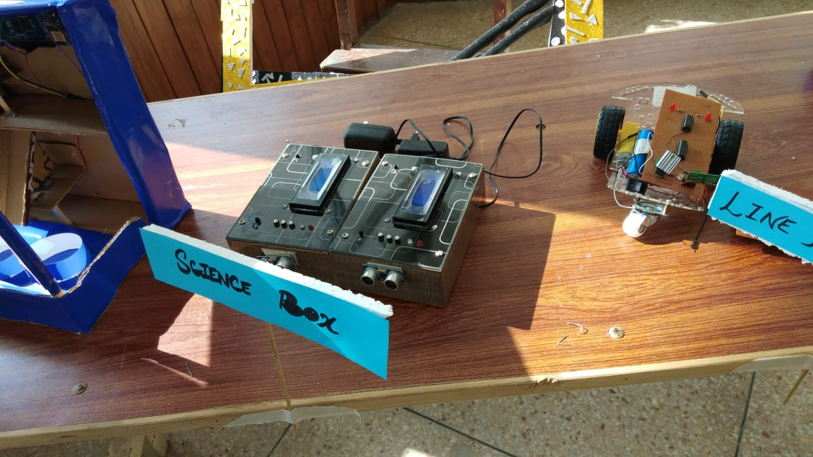

### Note

Infrared Sensor

Speed can be measured by an infrared (IR) sensor. An infrared sensor is an electronic instrument that senses intensity infrared radiation. The intensity reduces when an object blocks the radiation and thus this sensor can be used to detect presence or absence of an obstacle.

Buzzer

The sound is created by inducing rapid movements in the diaphragm of the buzzer. In electronic buzzers these vibrations are made by an electric circuit to produce the sound.

RGB LED Light

An RGB LED can glow red, green and blue. Such LEDs alter the power for each of the three colours to create a specific colour mix.